Receipt Keeper Deployment Guide

# introduction

Receipt Keeper is composed of Node.js server, MongoDB, AngularJS, and Android application (Fig. 1). Although the development was conducted on HEROKU PAAS, mLab DAAS environment, this document will explain about the deployment of the application at a local server using locally installed MongoDB.

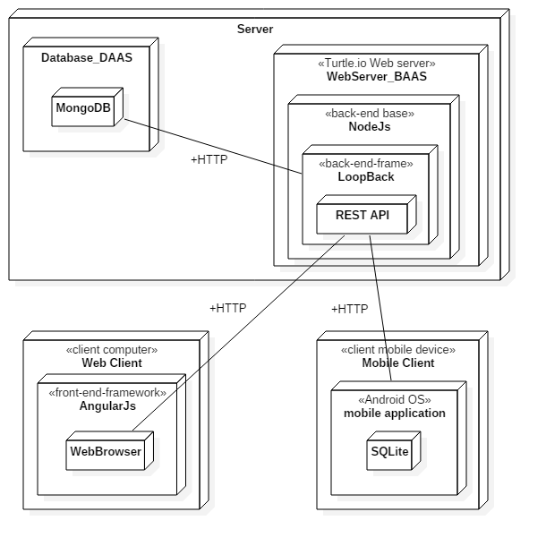

Fig. 1. Deployment Diagram

# Requirements

There is no specific requirement regarding OS and Hardware. For software, we have used following versions, but the latest versions with the same sub versions have no problems.

- NodeJS v4.4.0  
- Mongodb v3.2.1

# Set up Mongodb

a) Download MongoDB from this site:

<https://www.mongodb.com/download-center#community>

For Windows 7 or newer version, download Windows 64-bit 2008 R2+

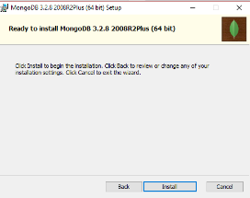b) On successful installation of the mongo database, we have to set the Mongo installation path “C:\Program Files\MongoDB\Server\3.0\bin” under the System Path variables so as to get the mongo commands recognized.

c) To setup user and password, open terminal window

mongod --dbpath the location where you want to create the database. For example --dbpath "c:\Users\your user name\Products\Mongo\database”

This will start the mongo server and it will listen on the default port 27017

d) Open another terminal window, and run mongoshell and add user and set the role

# INSTALL NODE.JS / npm

C:\Users\Changho Choi> mongo

MongoDB shell version: 3.2.8

connecting to: test

> use receipt_keeper

switched to db receipt_keeper

> db.createUser({user:"receipt_keeper", pwd:"12345",roles:[{role:"readAnyDatabase",db:"admin"},"readWrite"]})

Successfully added user: {

"user" : "receipt_keeper",

"roles" : [

{

"role" : "readAnyDatabase",

"db" : "admin"

},

"readWrite"

]

}

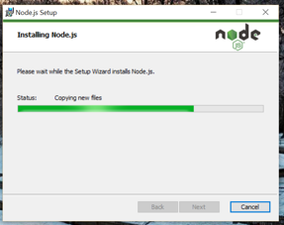Download NodeJS from this site: <https://nodejs.org/en/download/>

During the install,

Select option "Add to PATH"

Install npm package manager as well.

# set up datasource.json

Modify ~/server/datasources.json to setup data source as MongoDB.

The username, password, database name are the same as the information set at Step3

"MongoDB": {

"host": "localhost",

"port": 27017,

"url": "mongodb://localhost:27017/receipt-keeper",

"database": "receipt-keeper",

"password": "pass",

"name": "MongoDB",

"user": "admin",

"connector": "mongodb"

}

# install relevant npm modules

rm –rf ./node_modules

npm install

7. Running Mongodb Daemon

mongod –dbpath *~/mongodb/data*

# 8. Running nodejs server

node ./server/server.js

# install android application

1. Download and install the adb. This will not be covered here. Please refer to <https://developer.android.com/studio/command-line/adb.html> for the details.
2. Move to the folder where the apk is located and install the app with the following command:

adb devices

adb install receipt_keeper.apk

1. Run the android application and proceed to sign up (before running the android application, the server should be running). After signup, if the auto-login checkbox is checked, it will login automatically. On the settings menu, select Server Address and set the address of the server. After setting this, data is uploaded by use of the address.

 